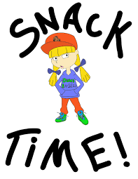

Dear Parents,

One of the first questions students ask on the first day of school is, “When is lunch?” Another common questions is, “Will we have snack time?”
First grade will have time for snacks during bus dismissal. If you would like your child to have a snack during that time, please provide a small, healthy snack that that can be eaten during that time. Students may eat their snack as soon as they are packed up and ready to go home. Some students, such as car riders and the early buses, may not have time to eat their snack before they are called for dismissal. They are dismissed around 3:40. Some students’ buses do not arrive until 4:05. Those students will have more time to eat their snacks. Staying hydrated in school is important. The students may keep a bottle of water on their desks. The water must be in a thermos style bottle. Plastic water bottles such as Deer Park or Dasani are not acceptable. The bottles tip over and spill very easily. The images on the back of this paper show examples of what kind of bottles are acceptable, and which ones are not acceptable.
Thank you for your support. I am looking forward to a great year.
Sincerely,
Mrs. Ellison

Acceptable water bottles

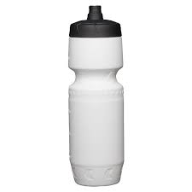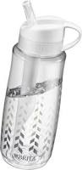

Not acceptable water bottles

